1836
A manifesto for Houston
By: Ali Mamujee
The Stakes

Houston is at the moment that decides the next fifty years.

The coasts have written us off as an aging energy town. The talent pipeline that built this city in oil and medicine is being courted by Austin, Miami, San Francisco. The AI era is the largest economic shift in a generation, and the coastal narrative is that it will be built somewhere else.
We have until August 30, 2036, the city's two-hundredth birthday, to prove them wrong. Ten years. One decade. The shortest stretch of time in which a city can either claim its next chapter or watch someone else claim it for them.

1836
The Allen brothers bet on a city. We are betting on what rises from it.
On August 30, 1836, two New York brothers named Augustus and John Kirby Allen ran a full-page advertisement in the Telegraph and Texas Register announcing the founding of the Town of Houston. They had purchased 6,642 acres of mosquito-infested swamp on Buffalo Bayou six days earlier for $5,000. They had no port. They had no railroad. They had no working steamboat dock. The bayou they promised was navigable was, at the moment they wrote the words, mostly impassable. They had a printing press, a piece of land everyone said was worthless, and one sentence so audacious it became the founding line of an American city: "Nature appears to have designated this place for the future seat of Government."
Within 15 months, Houston was the capital of the Republic of Texas. Within 70 years, oil discovered nearby made it one of the wealthiest cities in the world. Within a 130 years, a control room twenty miles south guided three astronauts to the moon. The Allen brothers founded a city the same way they would have founded a company: with conviction, a marketing document, and the willingness to be wrong in public until they were right.

They were the first founders of Houston. Two centuries later, the city is ready for the next ones.

2026
Houston is rising again, and the signs are everywhere.
The Ion sits in the old Sears building on Main Street, full of founders who chose Houston when they could have chosen anywhere. The Texas Medical Center has quietly become the largest applied AI campus on the planet, and almost no one outside the city knows it yet. The energy companies in the Energy Corridor are some of the most aggressive enterprise AI buyers in America, hiring engineers who five years ago would have only worked in San Francisco. The Ion District is filling with the kind of builders who used to leave for Austin and now choose to stay. Greentown Labs, Rice Nexus, the Cannon, Allen's Landing being reborn as a connected park system that finally treats the bayou the way the Allen brothers said it should be treated. There is a city being built underneath the city the rest of America thinks they know.
This is the second rising. The phoenix moment Houston has been waiting for since the oil money started to age out, since the coastal narrative wrote us off, since the talent began choosing Austin and Miami instead. It is happening right now, in the buildings and the conversations and the talent that is choosing to stay, and almost no one outside Houston has noticed.
I named this firm Allenix for both halves of the moment. Allen for the two brothers who bet on a swamp and built a city. Phoenix for what is rising from that city now, two centuries later, in the only ten-year window that matters.
What Houston does not have, and what every great rising moment requires, is a firm built specifically to help its operators win the next era. Not a coastal consultancy that flies in. Not a Big 4 transformation team. A firm that was built here, by people who have built and exited real businesses here, that helps the founder-led operators of the Gulf South use AI to compound what they already have. A firm that understands that the next great American business builders are not in Palo Alto. They are in Houston, Tulsa, Birmingham, Nashville, Midland. They have been underestimated by the coasts for forty years and they are about to be underestimated again, and that is the asymmetric bet of the decade.
We have ten years to build that firm.
THE BET

Three units, one brand

Allenix Labs is the engine. We install an agentic growth operating system inside mid-market companies, connect it to their existing stack, and deploy the platform, the playbooks, the consulting, the training, and the forward-deployed team that runs it alongside the customer. A mid-market CEO hires Labs because they want the AI-era growth team they have been reading about, without having to build it themselves.

Allenix Studios is the audience and the megaphone. Editorial, podcast, video, longform, and operator dinners that make Allenix the trade publication of the operator-led growth category, produced from Houston for the rest of the country to read. Studios builds the brand that brings every customer to the door, and it is how we make Houston louder to a country that has not been paying attention.
Allenix Capital is the compounding arm. We use cash flow and capital partners to acquire small operator services businesses, migrate them onto the Labs platform, plug them into the Studios audience, and unlock two to three times the enterprise value the previous owners ever could. Capital is how we turn one good firm into a portfolio of compounding ones.

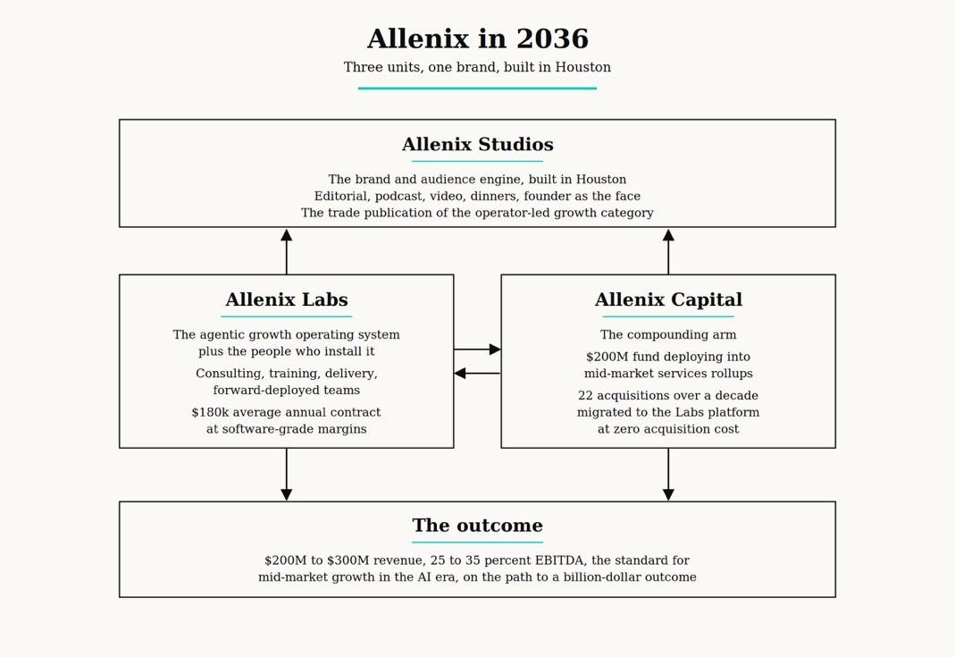
The 3 units are not a holding company. They are a single machine with three arms, and each arm makes the next one stronger. Studios builds the audience. Labs sells into the audience and runs inside every customer. Capital acquires the customers Labs has already validated. Labs deploys into the acquired companies on day one of the deal. Studios turns every win into the next chapter of the audience. The brand at the center compounds every quarter, in a city that grows louder every time the wheel turns.

This is not a services firm. This is not a media company. This is not a fund. It is all three, structured so that each one makes the next one inevitable. Built in Houston because Houston is where the next era will be most underestimated by everyone who doesn't live here.
2036
On August 30, 2036, Houston turns 200 years old.
By that day, Allenix will be the firm mid-market operators across the Gulf South know by name. A building in the Ion District with the Allenix name in cut steel above the door. A platform running inside hundreds of companies that would have otherwise been overlooked by the AI era. A trade publication produced from Houston that the rest of the country reads to understand where American business is actually being built. Engineers and AI talent who chose Houston because Allenix made it possible to build a serious career here without moving. A capital arm that has turned the founder-led economy of the Gulf South into a compounding portfolio. A brand that, two centuries after the Allen brothers' ad ran in the Telegraph and Texas Register, makes the case that they were right about what this place could become.
Houston will turn 200 either way. The question is what we put in front of the city when it does.
THE INVITATION
It’s a Saturday.
August 30, 2036. Houston turns 200.
We will be standing in front of a building in the Ion District with the Allenix name in cut steel above the door. The team is inside. The work is done. The city is bigger and louder than anyone outside Houston thought it would be, and we are part of the reason why.
Allenix is the bet. The next ten years are the work.

Let's go.

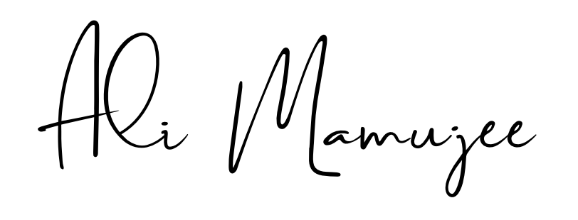

Ali Mamujee
Founder, Allenix

P.S. I bought Allenix.com domain today

